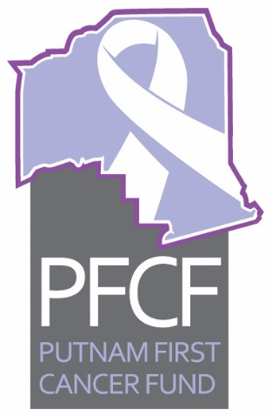
PFCF
Executive Committee Meeting Agenda
September 8, 2020, 2:00 pm

I. Call to order
II. Approval of minutes for August 11, 2020
III. Old Business
- Update on golf tournament cancellation - Vernon, Linda
- IRS Form 990 filing - Roxane
- Update on any other Old Business items
IV. New Business
- Palatka Christian Service Center Report August 2020 - Sheila McCoy
- Treasurer’s Report for August – Roxane
- Restrict Funding Report on Clay Electric Grant – Roxane
- Monthly Financial Audit Review Report – Vernon
- Any other new business

The next meeting is scheduled for Tuesday, October 13, 2020 at 2 pm via Zoom hosted by Dr. Kuruvilla.

