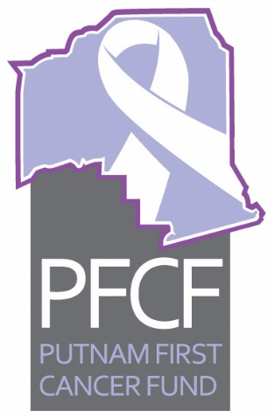
PFCF
Executive Committee Meeting Agenda
January 14, 2020, 2:00 pm

- Call to order
- Approval of minutes for November 12, 2019
- Old business
  - Update on Low Dose CT project—PowerPoint: Anand
  - Update on stop smoking campaign letter to potential clients—Mary G
  - Update on Rotary Health Fair—Anand and Mary G
  - Update on trivia contest—Mary C
  - Update on FLASCO final report by Dianne Taylor—Linda
  - Update on any other old business items
- New business
  - Palatka Christian Service Center(PCSC) Report for December 2019—Sheila
  - Treasurers report for December—Ken
  - Restrict Funding Report on Clay Electric grant—Ken
  - Report on computer purchase—Linda and Roxane
  - Monthly financial audit review—Vernon
  - Report on Trustees meeting—Vernon and Linda
  - Other new business
The next meeting is scheduled for Tuesday, February 11, 2020, at 2 pm, at the Cancer Center.

