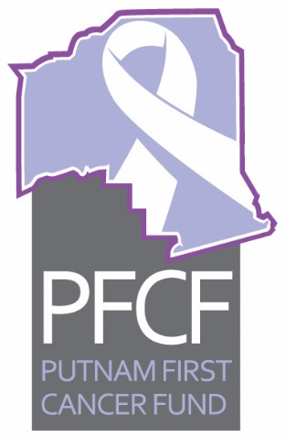
PFCF
Executive Committee Meeting Agenda
November 12, 2019, 2:00 pm

- Call to order
- Approval of minutes for October 8, 2019
- Old business
  - Update on Low Dose CT project—PSA: Mary C.
  - Discussion on possible change in recording votes on expenditure of funds for clients—Roxane
  - Update on stop smoking campaign letter to potential clients—Mary G
  - Update on Pink Out Putnam event—Debbie
  - Update on Palatka’s PorchFest: non-profit vendor area and banner text—Linda
  - Update on any other old business items
- New business
  - Palatka Christian Service Center Report for October 2019—Sheila
  - Treasurers report for October—Ken
  - Restrict Funding Report on Clay Electric grant—Ken
  - Use of debit and credit cards—Ken
  - Monthly financial audit review—Vernon
  - Other new business
The next meeting is scheduled for Tuesday, December 10, 2019, at 2 pm, at the Cancer Center.

