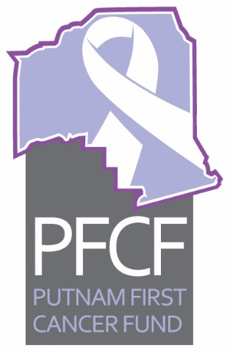
PFCF
Executive Committee Meeting Agenda
December 7, 2018, 12:00 pm

- Call to order
- Approval of Minutes for November 2, 2018
- Old business
  - Update on Palatka Men’s Golf Association fundraiser—John and Anand
  - Update on accepting electronic donations on our website—Linda
  - Update on solicitation of funds form to be filed with the State of Florida—Ken
  - Update on Low Dose CT education project for early detection of lung cancer—Anand
  - Update on resource development activities—Dianne
  - Update on meeting times for 2019—Linda
  - Update on Trivia contest in February 2019—Mary S
  - Update on any other old business items
- New business
  - Palatka Christian Service Center Report for November 2018—Sheila
  - Treasurers report including encumbrances—Ken
  - Restricted funding report, Clay Electric—Ken
  - Discussion about “Pink Out Putnam” donation—Anand and Linda
  - Other new business
The next meeting is scheduled for Tuesday, January 8, 2019, at 2 pm at the Cancer Center.

