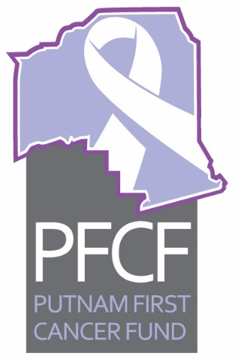
PFCF
Executive Committee Meeting Minutes
July 26, 2017 12:00 p.m.

Call to order at noon by Dr. Kuruvilla at the Cancer Center of Putnam. In attendance were Dr. Anand Kuruvilla, Vernon Myers, Taylor Douglas, Mary Makie Connor Saucier, Weezie Smith, and via phone Mary Garcia, Bobby Payne, and Dr. David Risch.

Approval of Minutes for June 28, 2017 and June Treasurers report. Motion for approval was made by Vernon Myers and seconded by Weezie Smith. Motion carried.

Old business
- Dr. Kuruvilla reported on the Oliver Grant funding press release and reported that Helen Curtis was working on it and would send it out to all members for input.

- Dr. Kuruvilla said we are now starting to receive the quarterly funds from United Way.

New business
- Weezie Smith reported on the accounting review. She was the only one of the committee there and said all was in order and that she and Holly had gone over the reports.

- The Palatka Christian Service Center Report for June 2017 was printed by Sheila McCoy for the board members. It is attached. Motion for approval was by Weezie Smith and seconded by Vernon Myers. Motion passed.

- Dr. Kuruvilla noted a meet and greet event inviting health professionals and members of Putnam Health Network was held to share information about PFCF and the services that are available to local patients. The event was held at the hospital July 13th with 30 people in attendance. It was well received.

- Dr. Kuruvilla reported on a check that was received from Debbie Siegrist for a memorial for Kenneth L. Biggs. The question came up about Siegrist being a member of a Relay for Life team. Dr. Kuruvilla contacted Ms. Siegrist via phone to clarify that she wanted the donation to go to PFCF. She said that was her intention and she followed up with a letter to that effect. The check will be cashed and a thank you will be sent.

- Weezie Smith reported that a group from Palatka headed up by Leslie Mullins was holding a “Pink Out” event in October to celebrate Breast Cancer Awareness and the group wanted to donate funds collected to PFCF. The group was requesting the PFCF logo for their information they were distributing on the event. There was no objection so Weezie will send the group our logo.

- Mary Garcia reported that she had talked with Putnam County School Superintendent Rick Surrency about having a breast cancer awareness program at Palatka High School, Interlachen High School, Crescent City High School and QI Roberts High School. No date has been set but it would probably be about three weeks after school started. She is working on setting a date or dates and said the response has been favorable.

The next meeting is scheduled for Wednesday August 23, 2017, at 12 p.m. at the Cancer Center of Putnam. The PFCF Trustees meeting will be held Monday August 14 at noon at the Cancer Center of Putnam.
Respectively submitted,
Mary Makie Connor Saucier
Secretary

