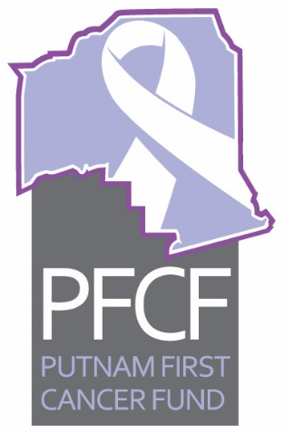
PFCF
Executive Board Meeting Minutes
February 22, 2017 12:00 p.m.

- Call to order at noon by Dr. Kuruvilla at the Cancer Center of Putnam. In attendance were Dr. Kuruvilla, Ken Mahaffey, Vernon Myers, Caroline Tingle, Weezie Smith, Mary Connor, Helen Curtis, and Mary Garcia

- Approval of Minutes for January 25, 2017. Motion was made by Weezie Smith and seconded by Vernon Myers. Motion for approval passed.

- Old business
- Proposed Accounting Procedures- still being worked on by John Rowe
- Helen Curtis report for the United Way is pending and Oliver Grant we need to ask for money for something different. Helen suggested we as for $10,000 to use for help with patients requiring home health care.
- Mary Garcia breast cancer interim report is being worked on. Mary will work with Helen on the United Way report.
- Three members will serve on the Financial Review Committee for the next year. They are Caroline Tingle, Helen Curtis and Weezie Smith. Ken Mahaffey made the motion to accept the three nominees to be on the committee and Vernon Myers seconded it. Motion passed.

IV. New business
- Treasurers Report for January 2017 was presented by Treasurer Ken Mahaffey. Vernon Myers made a motion to accept and it was seconded by Weezie Smith. Motion carried. (report attached)
- Palatka Christian Service Center Report for January 2017 was in paper form from Sheila McCoy. Weezie Smith made a motion to accept and it was seconded by Vernon Myers. Motion passed. (report attached)
- Trivia Tournament fundraiser report was given by Mary Makie Connor Saucier who noted that $4021 was raised at the annual event held on January 18th at Ravine Garden Civic Center.
- A gift acceptance policy was handed out in draft form by Caroline Tingle to all members for them to review and bring back to the next meeting.
- The audit committee members suggested after reviewing the 2017 through 015 recipients of the moneys and services by PFCF that the patients should sign a consent for treatment and giving permission for our audit committee to look at their files and medical records in reference to funding. Caroline Tingle will look at appropriate wording and bring it back before the board.
The audit committee established a five point check of each patient file: Referral, Eligibility, Dialogue with the provider for cost, majority board approval, and status on paid or not paid.
The audit committee reported on their findings for 2017 from 01 to 05 cases. Vernon Myers moved for acceptance of the report of the financial review committee and Ken Mahaffey seconded the motion. Motion passed.
The next meeting is scheduled for March 29, 2017 at 12 p.m. at the Cancer Center

