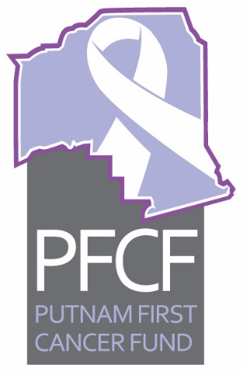
PFCF
Executive Committee Meeting Minutes
November 16, 2017 12:00 p.m.

- Call to order at noon with Dr. Kuruvilla, Ken Mahaffey, Taylor Douglas, Caroline Tingle, Vernon Myers, Bobby Payne, Charlie Douglas, Linda Girardin, Mary Makie Connor Saucier, Mary Garcia and non-committee member Sheila McCoy in attendance.
- Minutes were approved from the October 19, 2017 meeting. Vernon Myer moved and Ken Mahaffey seconded the motion and it passed.
- Old business
- Mary Garcia gave a report on the Oliver Grant and the United Way funding. Mary will work on a news release on the Oliver Grant. A photo shoot with Joyce Oliver from the Oliver grant was taken November 15 to include with the release. Another home health sharing event needs to be scheduled. Mary said she had attended a United Way meeting and told them about the sitting services, bi-fold distribution and education. $1300 has been spent so far from the grant.
- Breast Cancer Foundation Grant report from Linda Girardin was given saying it is now a bi-fold (Accuboost) flier. Mary Garcia suggest the local PAL Police Athletic League could fold, put labels and seal the edges of the bi-fold mailings. Girardin said she purged old addresses from a data base and ended up with 3761 names. The cost of the fliers was $3400. Dr. Kuruvilla reported the hospital will let us use their bulk mailing for the Accuboost breast cancer mailout.
- Caroline Tingle is still in conversation with a person to replace Helen Curtis.
- A review of our records took place with members Weezie Smith (absent from the meeting), Vernon Myers and Caroline Tingle before the meeting and a report is attached. The quarterly review of records will begin in January.
- Mary Makie Connor Saucier reported she is filing notes and materials from PFCF into a cabinet at the Cancer Center of Putnam meeting room. Dr. Kuruvilla had generously offered a storage cabinet for the groups minutes and other materials at the Cancer Center of Putnam.
- Carolyn Tingle reported on the shower cards distribution. We have extra to hand out at events. They will be put in goodie bags to be given out at the college’s “Girls Can” event in March. They were paid for by monies from United Way.
- New Business
- Treasurer’s Report for October 2017 was given by Ken Mahaffey. Linda Girardin moved to accept and Taylor Douglas seconded the motion and it passed.
- Palatka Christian Service Center report was given by Sheila McCoy.
- An accounting review report was given by Caroline and it is attached. Mary Garcia requested adding another category for grant monies or unspecified.
- David Bent with the fireman’s fundraiser for cancer group called “Black Sheep” came for a picture with the group following a sizeable donation. The “Pink Out” group also came for a picture and another sizeable donation.
- It was discussed about how much money to give to the three women Breast Cancer survivors who are recipients of the “Black Sheep” memory donation. It was decided a $500 gift card be given to each woman in memory of David Bents late mother.
The next meeting is scheduled for Wednesday December 21, 2017 at noon at the Cancer Center of Putnam.

